How to Set-up your Portal Account on your Phone

1. In your app store please find the app for Infinite Campus Mobile Portal
   1. 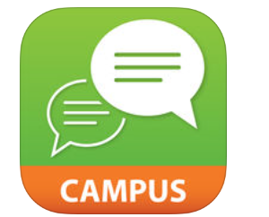
2. Type in District Name: Chandler and use the drop down to find Arizona to put in the state box.
   1. 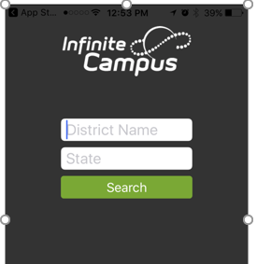
   2. Click Search
   3. 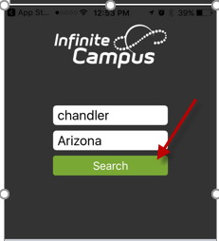
3. Chandler Unified School District will pop up, click on carat
   1. 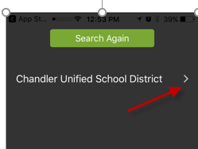
4. Please enter your username and password. If you do not remember your username and/or password, please contact your child’s school.
   1. 